Supermarket Sales Data Analysis Project Report
End-to-End Data Analytics Pipeline: Python, PostgreSQL, and Power BI

1. Project Overview
The objective of this project is to analyze historical supermarket sales data to extract actionable business insights. By integrating Python for exploratory data analysis and cleaning, PostgreSQL for relational database management, and Power BI for interactive visualization, this project provides a comprehensive view of store performance, customer purchasing patterns, and revenue distribution.

2. Dataset Summary & Preprocessing
The dataset used for this project is the Supermarket Sales dataset consisting of 1,000 transactions across 17 columns. The pipeline followed a rigorous data preparation workflow:
- • Data Loading: Loaded raw CSV records into Pandas DataFrame.
- • Initial Exploration: Inspected data types, column structures, and verified the total row and column counts (1,000 rows, 17 columns).
- • Missing Data Handling: Verified null values to ensure structural integrity across financial metrics and categorical attributes.
- • Column Standardization: Cleaned column names and formatted date/time fields to handle AM/PM text values for accurate time-based extraction.
- • Feature Engineering: Derived metric calculations and formatted numeric attributes to prepare tables for database integration.

3. Database Setup (PostgreSQL)
The cleaned dataset was imported into PostgreSQL to establish a robust relational schema. To handle text-formatted time columns (with AM/PM values), advanced casting techniques (`TO_TIMESTAMP`) and table alterations were performed to enable accurate time-series aggregation.

4. SQL Queries & Analysis Results
Below are the key SQL queries executed against the database, accompanied by their result outputs:

Query 1: Total Revenue by Branch
Results show leading performance across branches (e.g., Giza leading with ~$110.57K, followed by Alex with ~$106.20K).
SELECT Branch, SUM(Total) AS Total_Revenue
FROM supermarket_sales
GROUP BY Branch;

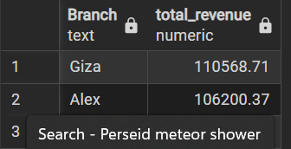

Query 2: Revenue by Product Line
Food and beverages (~$56.14K) and Sports and travel (~$55.12K) top the product revenue charts.
SELECT "Product line", SUM(Sales) AS revenue
FROM supermarket_sales
GROUP BY "Product line"
ORDER BY revenue DESC;

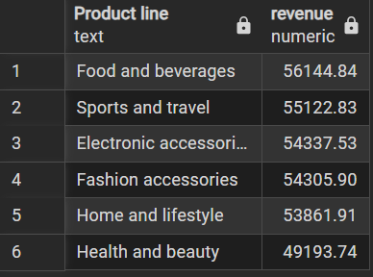

Query 3: Member vs. Normal Customer Average Spend
Members show a higher average spend (~$335.74) compared to Normal customers (~$306.37).
SELECT "Customer type", ROUND(AVG("Sales")::numeric, 2) AS avg_spend
FROM supermarket_sales
GROUP BY "Customer type";
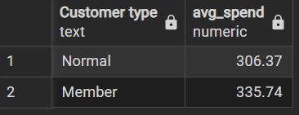

Query 4: Gender-Based Spending & Preference
Female customers average higher spend (~$340.93) than Male customers (~$299.06).
SELECT "Gender", ROUND(AVG("Sales")::numeric, 2) AS avg_spend
FROM supermarket_sales
GROUP BY "Gender";

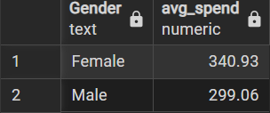

Query 5: Transaction Count by Payment Method
Ewallet (345) and Cash (344) are the most preferred payment modes closely competing with Credit card (311).
SELECT "Payment", COUNT(*) AS transactions
FROM supermarket_sales
GROUP BY "Payment"
ORDER BY transactions DESC;

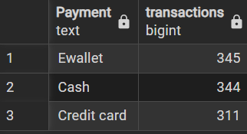

Query 6: Sales by Day of Week / Month

Objective: To analyze sales trends based on the day of the week.

SELECT TO_CHAR(sale_date, 'Day') AS day_of_week,
ROUND(SUM(total)::numeric, 2) AS total_sales
FROM supermarket_sales
GROUP BY day_of_week
ORDER BY total_sales DESC;

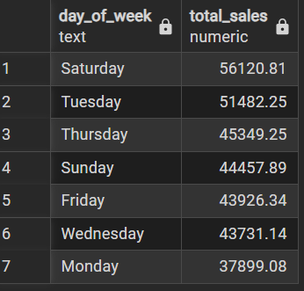

Query 7: Rating vs Sales Correlation

Objective: To examine the correlation between customer ratings and total sales.

SELECT CORR("Rating", "Sales") FROM supermarket_sales;

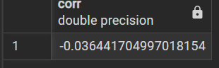

8. Top Product Line per Branch

Objective: To identify the top-performing product line in each branch using dense ranking.

WITH ranked_products AS (
SELECT branch, "Product line",
ROUND(SUM(total)::numeric, 2) AS total_sales,
DENSE_RANK() OVER (PARTITION BY branch ORDER BY SUM(total) DESC) as rank
FROM supermarket_sales
GROUP BY branch, "Product line"
)
SELECT branch, "Product line", total_sales
FROM ranked_products
WHERE rank = 1;

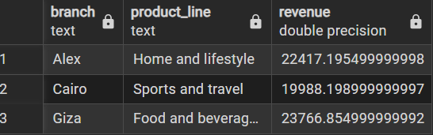

9. Gross Income Contribution by Product Line

Objective: To calculate the gross income contribution from each product line.

SELECT "Product line",
ROUND(SUM("gross income")::numeric, 2) AS total_gross_income
FROM supermarket_sales
GROUP BY "Product line"
ORDER BY total_gross_income DESC;

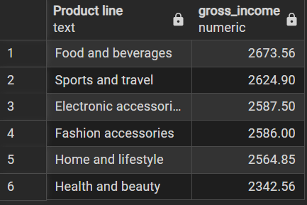

10. Peak Sales Hours Analysis

Objective: To determine the peak hours of the day when sales are highest.

SELECT EXTRACT(HOUR FROM time) AS sales_hour,
ROUND(SUM(total)::numeric, 2) AS total_sales
FROM supermarket_sales
GROUP BY sales_hour
ORDER BY total_sales DESC;
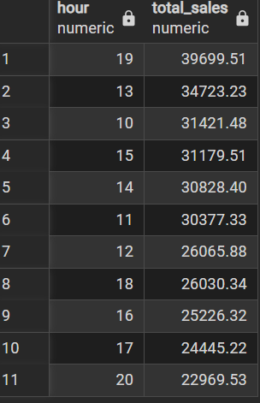

Food and beverages generated the highest gross income (~$2,673.56).
SELECT "Product line", SUM("gross income") AS gross_income
FROM supermarket_sales
GROUP BY "Product line"
ORDER BY gross_income DESC;

5. Data Visualization (Power BI Dashboard)
An interactive Power BI dashboard was built to synthesize key performance indicators, featuring branch filters, total revenue metrics, product line distribution donut charts, monthly sales trends, and payment preferences.
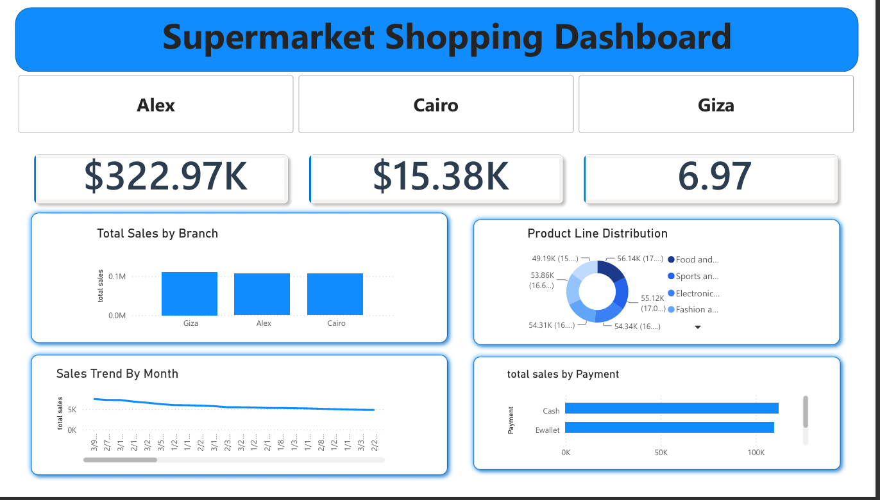

6. Business Recommendations
Based on the data insights extracted from the analysis, the following strategic recommendations are proposed for business growth:
- • Customer Loyalty Program: Leverage the higher average spend of Members (~$335.74) by expanding tier-based rewards and subscription perks.
- • Review Discount Policy: Optimize promotional structures around lower-performing product categories (e.g., Health and beauty) to increase conversion rates.
- • Product Positioning: Direct inventory and prominent shelf placement towards top-grossing categories like Food & Beverages and Sports & Travel.
- • Targeted Marketing: Capitalize on peak operational hours (such as hour 19 / 7 PM) by timing flash sales and digital push notifications.

7. Conclusion
This project successfully demonstrated an end-to-end data analytics workflow—starting from Python data cleaning, relational database aggregation in PostgreSQL, to interactive dashboard storytelling in Power BI. The resulting insights provide a solid foundation for data-driven retail management.

